Curriculum A - Long Term Curriculum Plan Year 3 & 4 2023 - 2024
“Inventors and Invaders – Britain and how it all began!”
As part of our two-year curriculum, this year has a strong history theme throughout, building a foundation of historical skills and knowledge. There are elements of the geography curriculum covered in the history topic
Year 3 / 4
 | Autumn 1 | Autumn 2 | Spring 1 |  | Spring 2 | Summer 1 | Summer 2
Computing | Data and Information – Branching Databases 3.4 (Y3)  Building and using branching databases to group objects using yes/no questions. | Data and Information - Data Logging 4.4 (Y4)  Recognising how and why data is collected over time, before using data loggers to carry out an investigation, | Creating Media – Stop-frame Animations 3.2 (Y3)  Capturing and editing digital still images to produce a stop frame animation that tells a story |  | Creating Media - Desktop Publishing 3.5 (Y3)  Creating documents and modifying text, images and page layouts for a specific purpose. | Programming A – Sequencing Sounds 3.3 (Y3)  Creating sequences in a block-based programming language to make music. | Programming B – Repetition in Games 4.6 (Y4)  Using a block-based programming language to explore count-controlled and infinite loops when creating a game.
Year 5 / 6
Computing | Data and Information – Flat-File Databases 5.4 (Y5)  Using a database to order data and create charts to answer questions. | Data and Information – Introduction to Spreadsheets 6.4 (Y6)  Answering questions by using spreadsheets to organise and calculate data. | Creating Media – Video Production 5.2 (Y5)  Planning, capturing, and editing video to produce a short film. | Creating Media – Web Page Creation 6.2 (Y6)  Designing and creating webpages, giving consideration to copyright, aesthetics and navigation. |  | Programming A – Selection in Physical Computing 5.6 (Y5)  Exploring conditions and selection using a programmable microcontroller. | Programming A - Variables in Games 6.3 (Y6)  Exploring variables when designing and coding a game.
Curriculum B - Long Term Curriculum Plan Year 3 & 4 2022 - 2023
“Awesome World”
Year 3 / 4
Computing | Computer Systems & Networks – Connecting Computers 3.1 (Y3) | Computer Systems and Networks - The Internet 4.1 (Y4)  Recognising that the internet is a network of networks including the WWW, and why we should evaluate online content. | Creating Media - Audio Production 4.2 (Y4)  Capturing and editing audio to produce a podcast, ensuring that copyright is considered. |  | Creating Media - Photo Editing 4.5 (Y4)  Manipulating digital images, and reflecting on the impact of the changes and whether the required purpose is fulfilled, | Programming B – Events and Actions 3.6 (Y3)  Writing algorithms and programs that use a range of events to trigger sequences of actions. | Programming A – Repetition in Shapes 4.3 (Y4)  Using a text-based programming language to explore count-controlled loops when drawing shapes.
  Identifying that digital devices have inputs, processes, and outputs, and how devices can be connected to make networks
Year 5 / 6
Computing | Computer Systems and Networks – Systems and Searches 5.1 (Y5)  Recognising IT systems in the world and how some can enable searching on the internet. | Computer Systems and Networks – Communication and Collaboration 6.1 (Y6)  Exploring how data is transferred by working collaboratively online. | Creating Media – Vector Drawing 5.5 (Y5)  Creating images in a drawing program by using layers and groups of objects. |  | Creating Media – 3D Modelling 6.5 (Y6)  Planning, developing, and evaluation 3D computer models of physical objects. | Programming B - Selection in Quizzes 5.6 (Y5)  Exploring selection in programming to design and code an interactive quiz. | Programming B – Sensing Movement 6.6 (Y6)  Designing and coding a project that captures inputs from physical devices.

National Curriculum purpose of study
- ‘The core of computing is computer science, in which pupils are taught the principles of information and computation, how digital systems work, and how to put this knowledge to use through programming.
- Building on this knowledge and understanding, pupils are equipped to use information technology to create programs, systems and a range of content.
- Computing also ensures that pupils become digitally literate –able to use, and express themselves and develop their ideas through, information and communication technology – at a level suitable for the future workplace and as active participants in a digital world.’

National Curriculum Content
The computing curriculum can be split into three strands
Computer Science | Information Technology | Digital Literacy
How computers and computer systems work.  How they are designed and programmed. | Technology in our lives and the purposeful use of existing programs to develop products and solutions. | The skills, knowledge and understanding needed to participate fully and safely in the digital world
Foundations | Applications | Implications

Digital Literacy – follows throughout Computing Science and Information Technology units
Computer Science | Information Technology
Computer Systems and Networks | Creating Media 1
Programming A | Creating Media 2
Programing B | Data and Information

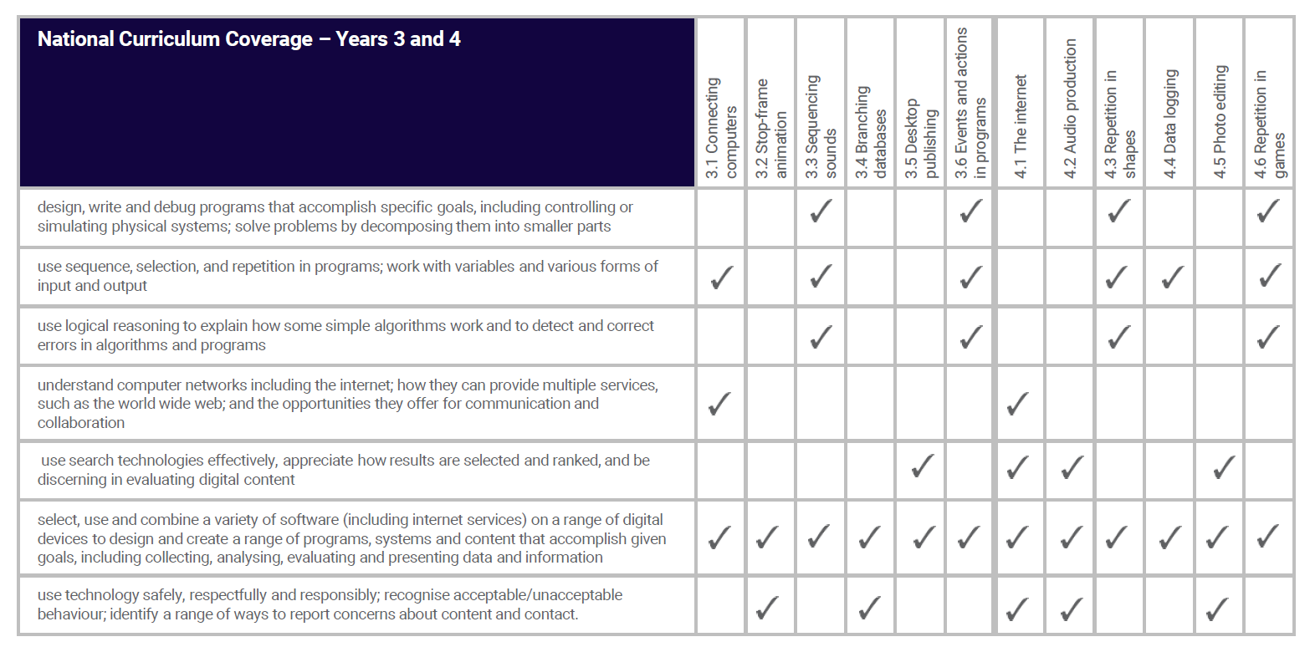
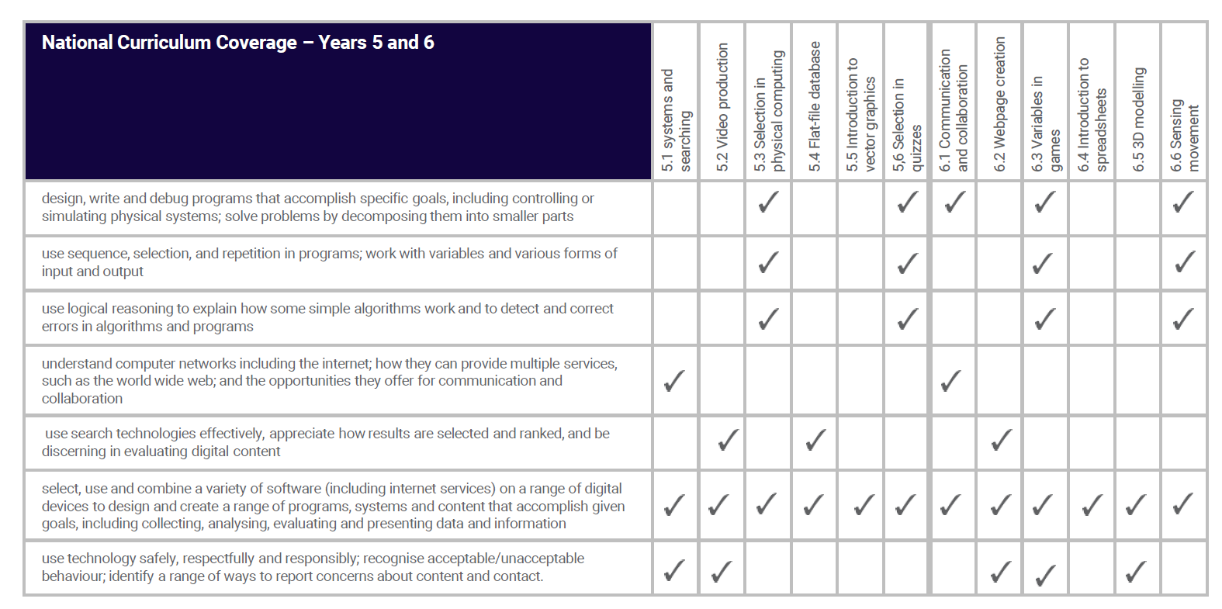

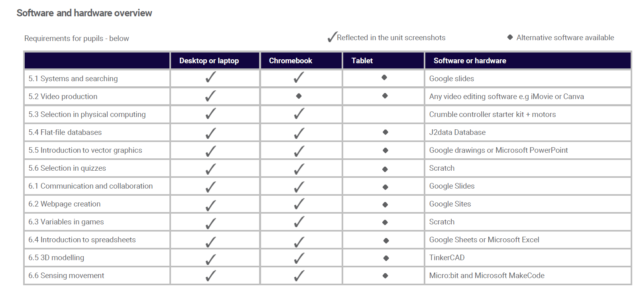
Progression
Information Technology - Data and Information
Through Year Groups
Year 3 | Branching databases | Building and using branching databases to group objects using yes/no questions.
Year 4 | Data logging | Recognising how and why data is collected over time, before using data loggers to carry out an investigation,
Year 5 | Flat-file databases | Using a database to order data and create charts to answer questions.
Year 6 | Introduction to spreadsheets | Answering questions by using spreadsheets to organise and calculate data.

Through Curriculum | Year 3 / 4 | Year 5 /6
Curriculum A | Data and Information – Branching Databases (Y3) | Data and Information – Flat-File Databases (Y5)
Curriculum A | Data and Information – Data Logging (Y4) | Data and Information – Introduction to Spread Sheets (Y6)

Computer Science - Computer Systems and Networks
Through Year Groups
Year 3 | Connecting Computers | Understanding digital devices and how they work. Recognising computers are connected within a network.
Year 4 | The Internet | Recognising the internet as a network of networks. Evaluating online content.
Year 5 | Systems and Searching | How computing systems share information. How search engines work.
Year 6 | Communication and Collaboration | How the internet works. How it facilitates online communication and collaboration.

Through Curriculum | Year 3 / 4 | Year 5 /6
Curriculum B | Computer Systems and Networks Connecting Computers (Y3) | Computer Systems and Networks – Systems and Searching (Y5)
Curriculum B | Computer Systems and Networks – The Internet (Y4) | Computer Systems and Networks – Communication and Collaboration (Y6)

Computer Science - Programming
Through Year Groups
Year 3 | Sequencing sounds  Events and actions in programs | Creating sequences in a block-based programming language to make music.  Writing algorithms and programs that use a range of events to trigger sequences of actions.
Year 4 | Repetition in shapes  Repetition in games | Using a text-based programming language to explore count-controlled loops when drawing shapes  Using a block-based programming language to explore count-controlled and infinite loops when creating a game.
Year 5 | Selection in physical computing  Selection in quizzes | Exploring conditions and selection using a programmable microcontroller.  Exploring selection in programming to design and code an interactive quiz.
Year 6 | Variables in games  Sensing movement | Exploring variables when designing and coding a game.  Designing and coding a project that captures inputs from physical devices.

Through Curriculum | Year 3 / 4 | Year 5 /6
Curriculum A | Programming A – Sequencing Sounds (Y3) | Programming A – Selection in Physical Computing (Y5)
Curriculum A | Programming B – Repetition in Games (Y4) | Programming A – Variables in Games (Y6)
Curriculum B | Programming B – Events and Actions in Programs (Y3) | Programming B – Selection in Quizzes (Y5)
Curriculum B | Programming A – Repetition in Shapes (Y4) | Programming B – Sensing Movement (Y6)

In each year group, there are two 'Programming' units of work, but only one 'Programming' learning graph. The second 'Programming' unit builds on the content that was taught in the first 'Programming' unit so closely that there is no specific divide where one ends and the other begins.

Information Technology - Creating Media
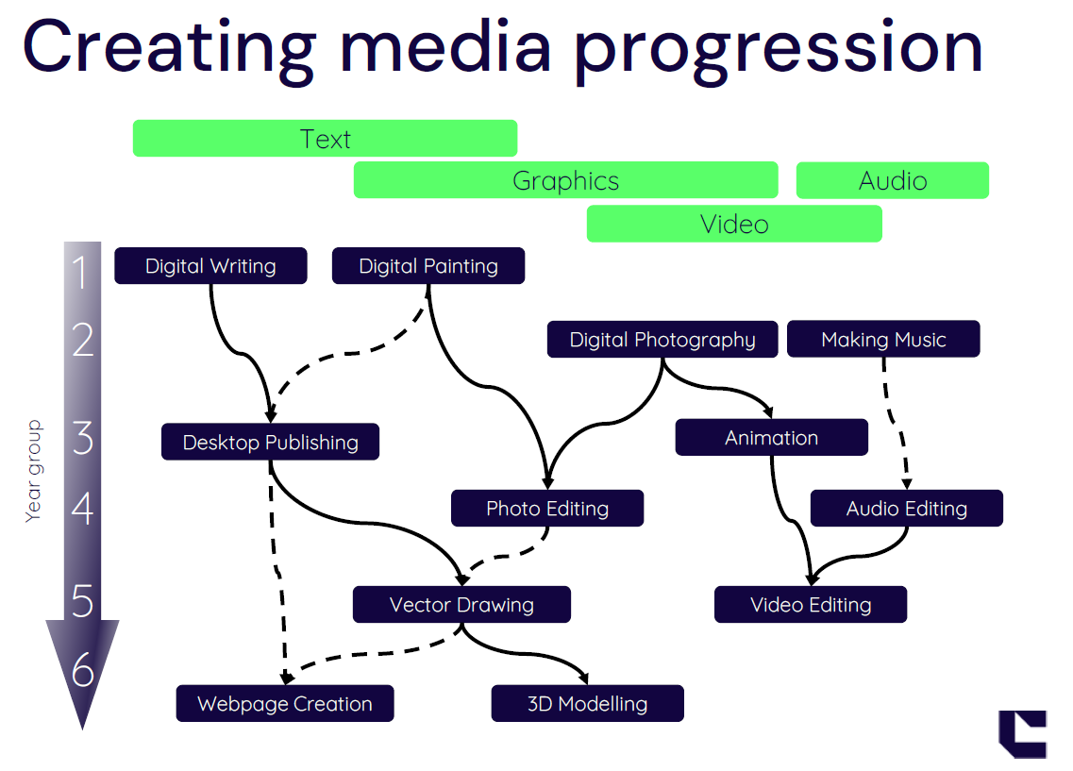

Information Technology - Creating Media
Through Year Groups
Year 3 | Stop-frame animation  Desktop publishing | Capturing and editing digital still images to produce a stop frame animation that tells a story  Creating documents and modifying text, images and page layouts for a specific purpose
Year 4 | Audio production  Photo editing | Capturing and editing audio to produce a podcast, ensuring that copyright is considered.  Manipulating digital images, and reflecting on the impact of the changes and whether the required purpose is fulfilled,
Year 5 | Video production  Introduction to vector graphics | Planning, capturing, and editing video to produce a short film.  Creating images in a drawing program by using layers and groups of objects.
Year 6 | Webpage creation  3D modelling | Designing and creating webpages, giving consideration to copyright, aesthetics and navigation.  Planning, developing, and evaluation 3D computer models of physical objects.

Through Curriculum | Year 3 / 4 | Year 5 /6
Curriculum A | Creating Media – Stop Frame Animations (Y3) | Creating Media – Video Production (Y5)
Curriculum A | Creating Media – Desktop Publishing (Y3) | Creating Media – Web Page Creation Y6
Curriculum B | Creating Media – Audio Production (Y3) | Creating Media – Vector Drawing (Y5)
Curriculum B | Creating Media – Photo Editing (Y4) | Creating Media – 3D Modelling (Y6)

Online safety

The unit overviews for each unit show the links between the content of the lessons and the national curriculum and Education for a Connected World framework (ncce.io/ efacw). These references have been provided to show where aspects relating to online safety, or digital citizenship, are covered within the Teach Computing curriculum. Not all of the objectives in the Education for a Connected World framework are covered in the Teach Computing curriculum as some are better suited to personal, social, health, and economic (PSHE) education; spiritual, moral, social, and cultural (SMSC) development; and citizenship. However, the coverage required for the computing national curriculum is provided

Assessment

Formative assessment
Every lesson includes formative assessment opportunities for teachers to use. These opportunities are listed in the lesson plan and are included to ensure that misconceptions are recognised and addressed if they occur. They vary from teacher observation or questioning, to marked activities.

These assessments are vital to ensure that teachers are adapting their teaching to suit the needs of the pupils that they are working with, and you are encouraged to change parts of the lesson, such as how much time you spend on a specific activity, in response to these assessments.

The learning objectives and success criteria are introduced in the slides at the beginning of every lesson. At the end of every lesson, pupils are invited to assess how well they feel they have met the learning objectives using thumbs up, thumbs down, or thumbs sideways. This gives pupils a reminder of the content that has been covered, as well as a chance to reflect. It is also a chance for teachers to see how confident the class is feeling so that they can make changes to subsequent lessons accordingly.

Summative assessment
Every unit includes an optional summative assessment framework in the form of either a multiple choice quiz (MCQ) or a rubric. All units are designed to cover both skills and concepts from across the computing national curriculum. Units that focus more on conceptual development include a MCQ. Units that focus more on skills development end with a project and include a rubric. However, within the ‘Programming’ units, the assessment framework (MCQ or rubric) has been selected on a best fit basis.

Multiple choice quiz (MCQ)
Each of the MCQ questions has been carefully chosen to represent the learning that should have been achieved within the unit. In writing the MCQs, we have followed the diagnostic assessment approach to ensure that the assessment of the unit is useful to determine both how well pupils have understood the content, and what pupils have misunderstood, if they have not achieved as expected.
Each MCQ includes an answer sheet that highlights the misconceptions that pupils may have if they have chosen a wrong answer. This ensures teachers know which areas to return to in later units.

Adapting the curriculum for pupils with SEND

The Teach Computing Curriculum has been written to support all pupils, with units containing a number of scaffolding activities and utilising effective pedagogies to ensure high quality teaching. However, you may still need to adapt resources to enable some of your pupils, for example those with special educational needs and disabilities (SEND), to access lessons fully.
The following principles will help you make adaptations that benefit all learners, and these will be more effective if you identify clearly what it is your individual pupils need help with -do they have poor working memory that means that following instructions is more difficult, or do they need help to stay focussed when completing projects?

1.Identify essential learning and misconceptions: Determine the key learning in each unit that every child should know. Provide repeated opportunities for pupils to revisit this content in different ways. Identify any likely misconceptions and address these explicitly in lessons. For example, in the year 3 Animation unit, pupils tend to move characters too far between frames, so ensure this is highlighted and modelled well.
2. Pre-teach key vocabulary: Pre-teach the essential vocabulary for each unit, provide learners with a word list supported by images and use the vocabulary regularly throughout the unit with a consistent definition. Concentrate on a small number of terms and consider using a graphic organiser to highlight relationships between concepts, e.g. the Frayer model.

3. Create step-by-step instructions: Break down complex tasks and routine skills for using software and hardware into smaller steps and create pictorial instructions for children to follow. For example, in year 4 Audio Editing, you could create a handout with a sequence of instructions for trimming audio clips in Audacity based on the video guide.

4. Provide templates: In Creating Media or Data & Information units, support task completion by providing a template for pupils to modify –removing the fear of the blank page and helping to build confidence. For example, in the year 6 Web Page Creation unit, you could set up a simple site with pages and navigation for pupils to fill in the content.

5. Consider non-computing barriers: Consider if difficulties in other areas, such as writing or maths, present barriers to completing a task and if so, modify the task to help mitigate these. For example, in the year 6 Communication and Collaboration unit, during lesson 3 where pupils work collaboratively to create slides, they could dictate content into the document rather than type it.

6. Use the PRIMM framework or Parson’s problems: In programming units, add extra scaffolding using PRIMM and Parson’s problems. Some pupils may not be able to create a program, but they can practise reading and exploring code in a working program, then modify it to make it more personalised. For example, in the year 4 Repetition in Games unit, for the final task learners can modify the bat catching game by changing the backdrop, adding a new costume to the sprites to change their appearance, and adding a different sound. The aim is to remove these scaffolds as children develop their skills, but some learners may not become fully independent.

7. Harness pupils’ special interests: Increase engagement and make learning more relevant by incorporating pupils' special interests. This is also important in terms of culturally relevant pedagogy. For example, in the year 5 Vector Drawing unit, pupils could use what they have learnt to create a logo for their favourite sports team.

8. Use unplugged activities and the semantic wave: We can use unplugged activities to help make computing concepts more relevant and understandable for learners. However, it is very important to ‘repack’ the knowledge of the abstract concept so that learners understand what it means in a wider context and they can use the technical language. For example, in the year 5 Selection in Physical Computing unit pupils consider examples of selection in everyday life. Children then need to see the link between these examples and how this is used in a program and have the opportunity to use the key language in context. Pupils with SEND may need repeated examples and smaller steps to repack the knowledge, e.g. you could provide learners with some printed selection blocks from the Crumble software to add everyday examples to.

9. Support planning: Break down the planning process into smaller parts which can be ticked off as each one is completed, and provide a planning scaffold for learners where required. For example, when planning out algorithms for Scratch, provide printed versions of the blocks to manipulate and order, to help pupils to focus on only the code required
10. Reinforce digital skills: A significant barrier to accessing the whole computing curriculum is a lack of key digital skills, for example being able to log on to a computer and use the keyboard effectively. Time spent revisiting digital skills across all units is important to develop fluency. Some pupils may also benefit from extra time to practise these skills in small groups, or may need image-supported help sheets to support specific repeated tasks, such as saving work.

